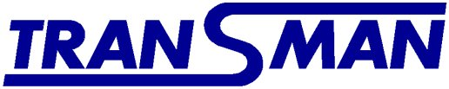
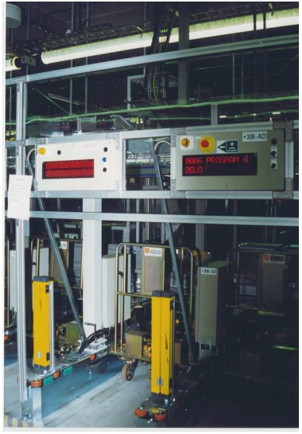

Introduction
Transman is a Swedish market leader among gantry robot manufacturers, and specialises in automated materials handling and machine loading. The company was started in 1983. Tranman’s program gives:

- Cost efficient production – higher accessibility
- Higher quality in production
- Improved working environment, less dangerous assignments, improved working quality
- Proper technological height in the process
- Good design

They target the Postal Handling, Materials Handling and Machine Loading markets with their product mix. The trend in these business areas is that the orders are complex and large and the supplier should be of ‘blue chip company’ status in order to be able to secure deliveries.
Transman is owned by a group of leading people in the company.

Targeted markets

Postal Handling
This business area has been the most successful within the Transman business portfolio. During 1995-98 it generated 60% of total turnover. There is a global trend within the Postal industry towards increased automation, especially in the mail handling process. Today the purchase decision is characterised by a centralised decision at a national ministry level. Due to the deregulation of the Postal Services, the purchase decision is likely to change and thereby give Transman new opportunities in these markets. Transman will prioritise this business area by attending exhibitions and approaching important customers throughout Europe. One successful case in this area is the co-operation with Sweden Post, where the system has been a great success, especially in the mail handling process. The total number of installations in this field is 52 loading and unloading systems to Sweden Post, Norway Post and China Post.

Machine Loading
The targeted industries for this business area are the metal industry, heavy automotive industry, paper industry and processing industry. In order to penetrate this market Transman will have to put a great deal of resources into marketing, since their concept is rather unknown at this point. One possibility to lower the marketing cost and still penetrate the market is to join forces with system integrators. Partners in Sweden so far have been Moving, Evert Johansson, Erikkilä. The total number of installations in this field is 58 units, with customers in the automotive industry such as Volvo, Saab, Scania and Acrivia (Volvo Bus).

Materials Handling
The current position in this segment has been carefully selected due to the intensity of competition in the business area. This business area should be segmented based on the level of automation, with Transman targeting the segment with the most automated customers due to their leading edge technology. One way of approaching customers in this segment could be to join forces with suitable system integrators. Partners in Sweden so far have been Prevas and AKV. The total number of installations in this field so far is 31 robot systems, with customers such as Sandvik Steel, ABB, Tetra Pak International, Polyclad and Perstorp.

After Sales Market
With nearly 150 units installed, the after-sales market is extensive, and an important part of Trainman’s business. For the customers, the support level is a decisive factor when choosing a supplier. The services to the customers’ means:
- Increased accessibility and thereby increased profitability for the customers.
- Instant feedback regarding our products and markets.
- A possibility to educate our customers’ project engineers.
- The opportunity to sell long-term service contracts for all robotics deliveries.
Transman aims to develop and strengthen the after-sales market. As important as the actual maintenance are the software support and the upgrading of older installations to new applications and better performance.

Products

Transman has developed a modular gantry robot system with very high capacities. Patents protect many products in the product mix. The gantry robots are based on MODAL, a system of modular components, patented and registered by Transman. The rigid Modal profiles have a clean design with small tolerances. A strong timing belt actuates the carriers inside the horizontal profile. This maintenance-free system is sealed against external contamination and thus unaffected by dirt. One speciality is grippers using high-flow vacuum technology for the handling of irregular products.

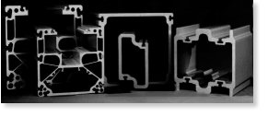
Modular design for high flexibility.

Due to the high level of technology, Trainman’s robots have a very high degree of availability and operational reliability, providing the customers with good profitability. Nevertheless, they are simple to use with the operator-friendly control system. Transman can handle all sorts of products, materials, and packages – quickly, quietly and carefully. Trainman’s equipment is sealed, durable and clean, and it can be used in most fields of industry, from aggressive industrial environments to hygienic pharmaceutical manufacturing. The product mix, comprising modular designs and standard robots, results in low costs and simple adaptation to the customer’s requirements. All products in the product mix are supported by Trainman’s own control system, Transcon. Transcon has the flexibility to control other machines as well.

Automated postal handling

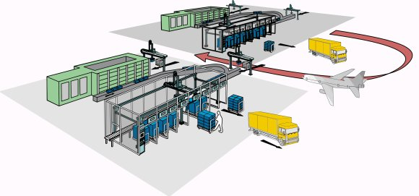

The new move in tray handling
Transman Robot Loading System
The Transman Tray Loading System (RLS) is a high capacity robot system developed to sort and handle trays or boxes. It is used in collection and distribution at automated postal sorting centres. The items are conveyed to the RLS where the trays are sorted according to the bar-code labels. Each tray is put on a carriage with the correct destination. The carriages are then transported to their final district for delivery. Multi-step sorting is also possible.

Materials Handling
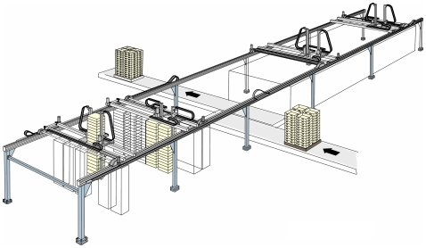

The Transman ’Materials handling’ concept is a flexible concept that manages different sizes of packages and pallets. The objects can be handled in parts or as a system. Trainman’s strength is in the robots’ flexibility. This flexibility is shown for instance by the ability to handle mixed objects on the pallets, and also by the ability to adapt the mechanics to almost any working area.

Machine Loading
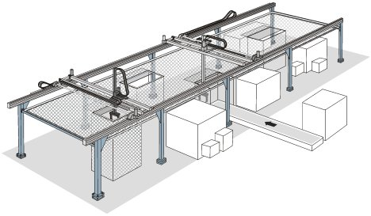
The Transman ’Machine Loading’ concept is characterised by heavy lifting at high speed with retained accuracy. In this concept, one single or a number of machines, can be loaded with specific items. In general, the machines are programmed in advance to work with a certain item. The robot collects the item from a starting point and puts the item into the machine. When the work is completed at one machine, the item may be brought to the next machine by the robot. This concept’s advantages are its capability to operate over large working areas, with multiple positions, with many item identities, process flexibility, mainly due to the highly advanced and suitable control system. This concept has a patented safety barrier system that gives it a unique technological edge in comparison with Swedish and international competitors.

